Wallrun Manual

To make the wall run you must get an input system for example, this will require Look, WASD, mouse, aim. Make sure each input has “Vector 2”.

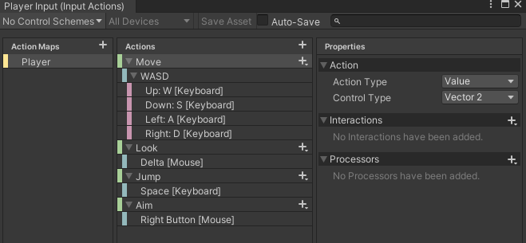

For tags design “Player”, “Wallrun”, Platform. This will allow the script for player control to tell what is the floor and what is the wall it can run on.

The script “Playercontroller” has no “AddForce” inside of it because the “Wallrun” script has no add force as it make the player stick to the wall that is label “Wallrun” as it tag.

For the character it can have any collider but it must have Rigidbody, Player Controller script, Wall run script, and it must have a player input system that on your project system must have an Input system old and new so you must put “Both”.

The player input must have action where it says “open input settings” This will allow your player to move around your game.

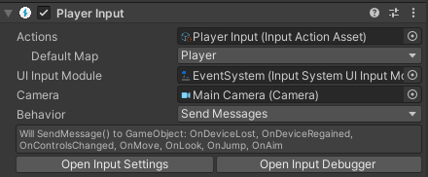

The Player Controller has a different function toward the player which you can adjust the same goes for wall run.

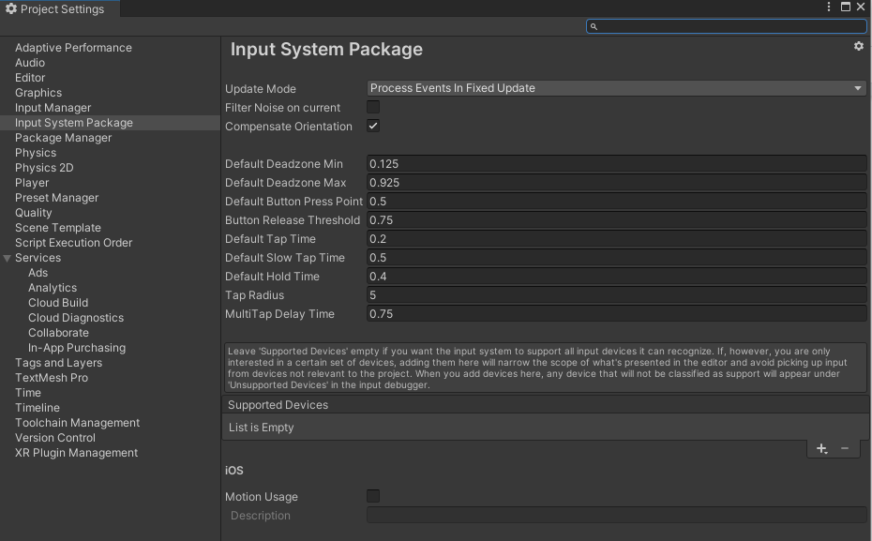

Make sure the update mode has “Process Events in Fixed Update” that works well toward your input system for the character controller.